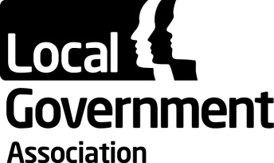 | LGA General Assembly  8 July 2014
LGA consolidated financial statements for the year to 31 March 2014
Purpose of the Report

To invite the General Assembly to receive the LGA consolidated financial statements for 2013/14.

The LGA’s consolidated financial statements for the year ended 31 March 2014 are included in the LGA Annual Report, enclosed with this agenda. They were reviewed by the Audit Committee on 3 June and approved by the LGA Leadership Board on 11 June. They are expected to receive an unqualified audit opinion from the external auditors PKF Littlejohn LLP. The auditors will sign the consolidated accounts once the financial statements for the individual companies feeding into the consolidated accounts have been adopted at their respective board meetings in June 2014.

This is the third year for which the LGA has prepared consolidated financial statements reflecting the changes made in 2011 to integrate the operations of the Association and its related bodies.

The financial statements show a consolidated surplus of £5.479 million before financing incoming costs, contributions from joint ventures, proceeds from the sale of shares and adjustments relating to additional pension contributions. The overall pension deficit increased by £16.367 million to £91.937 million. This valuation has been carried out in line with FRS17 accounting standards and is therefore subject to market performance on a specific date. The LGA is making additional pension contributions in order to eliminate the deficit over a period of between 15 and 22 years.

Recommendation

That the General Assembly receives the financial statements for the year to 31 March 2014.

Contact officer: | Helen Platts
Position: | Head of Finance and Business Management
Phone no: | 020 7664 3228
E-mail: | helen.platts@local.gov.uk

